DFHV TITLE VI COMPLAINT FORM

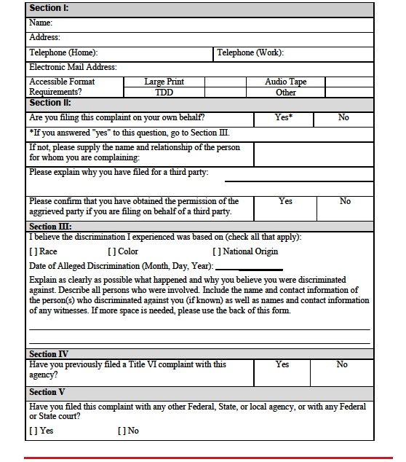

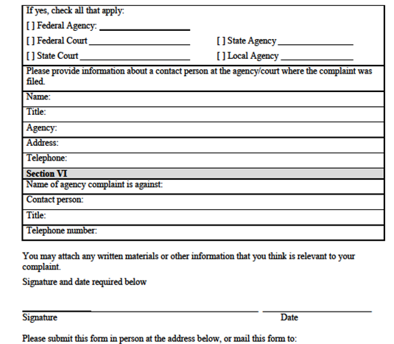

Title VI Manager
Wendy Klancher
DFHV
2235 Shannon Place SE
Washington, DC 20020
Or email it to DFHV@dc.gov

