DFHV Limo App User Guide:iOS
Background:
In FY 2017 the Department of For Hire Vehicles started a pilot program by where Non-District Limousines can complete point to point trips within the District limits. The program is being extended through FY 2018. The legacy system has been transferred to the DFHV central licensing platform. New applicants and companies wishing to extend their authority will need to access the new system to complete the registration process. In conjunction with the data migration a new DFVH Limo app has been implemented with improved authentication features and integration to the new system.
Registration and Login:
To install DFHV Limo app, open App Store App on your iPhone and type “DFHV Limo App” in the search field.
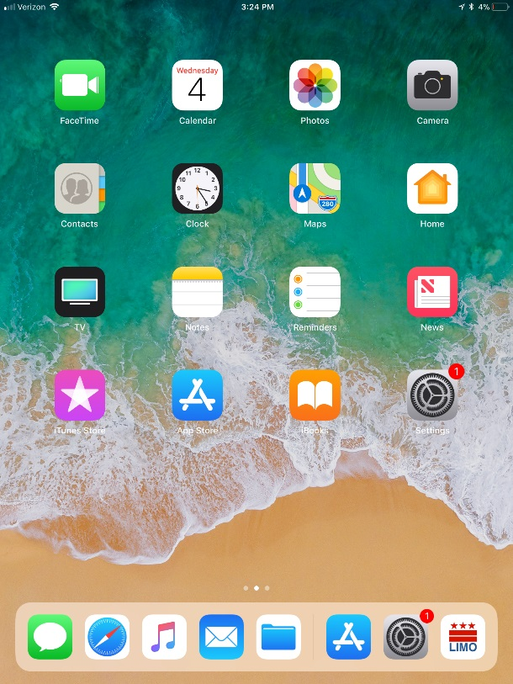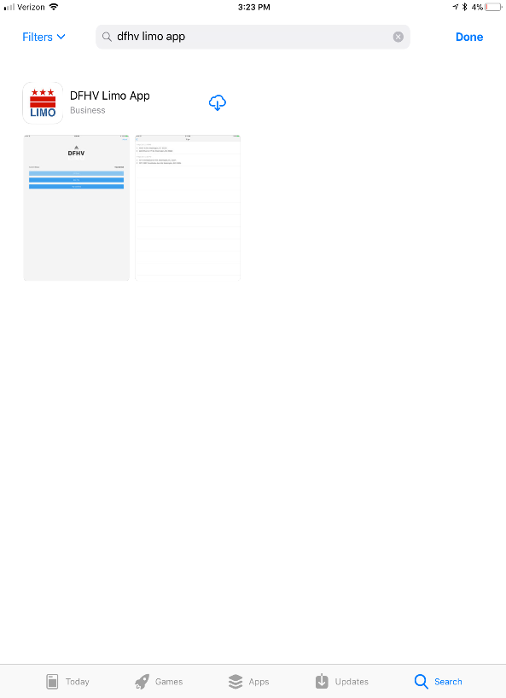

Wait until the setup is complete, then click Open Button.

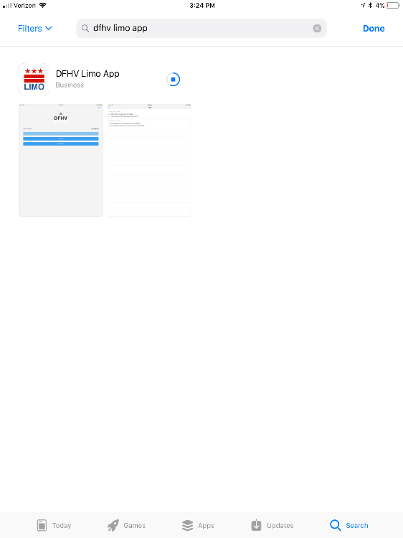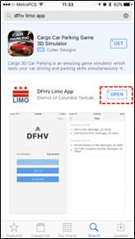

When the app is launched, it will request permission to send you notifications. Click Allow to enable app to send you notifications.
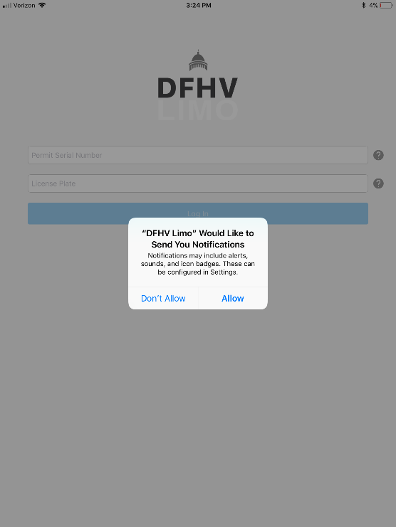

Login:
To login to the application enter the Driver ID and vehicle license plate number, then tap "Login" button. The Driver ID will be provided by the limo company. If the driver is registered with DFHV, he/she can enter the Face ID assigned to the driver:

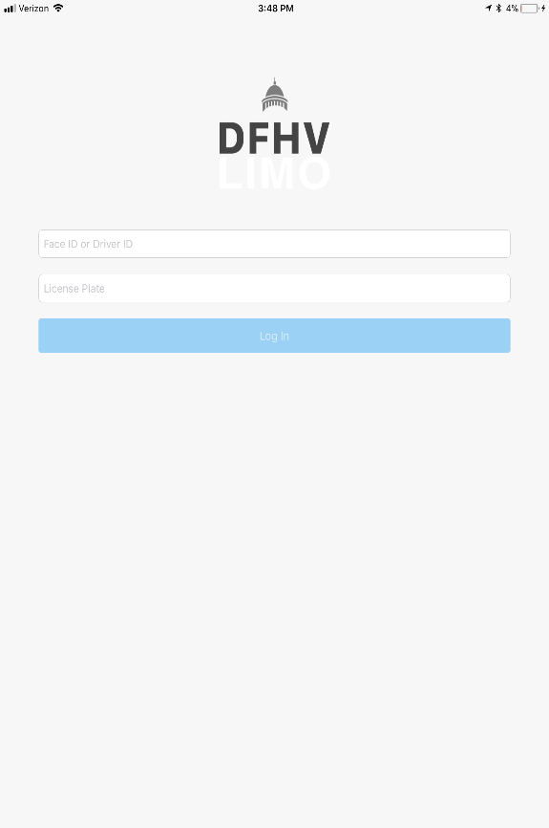

Tracking On/Off Duty:
After successful login, tap "On duty" button to start tracking on duty location (the text on the button will change to "Off duty"). To stop tracking location, tap "Off duty" button:
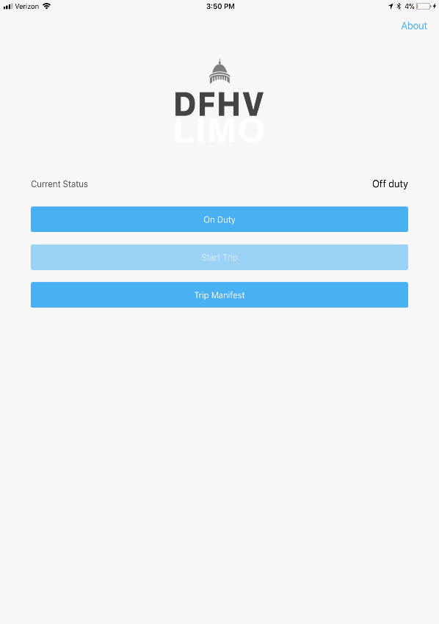
At some point the app will ask for permissions to track your location, click allow.

Tracking Trips:
Start Trip:
Tracking trips information only available in "On duty" status. Before starting the trip tap "Start trip" (Current status will change to "Trip started") and start driving:

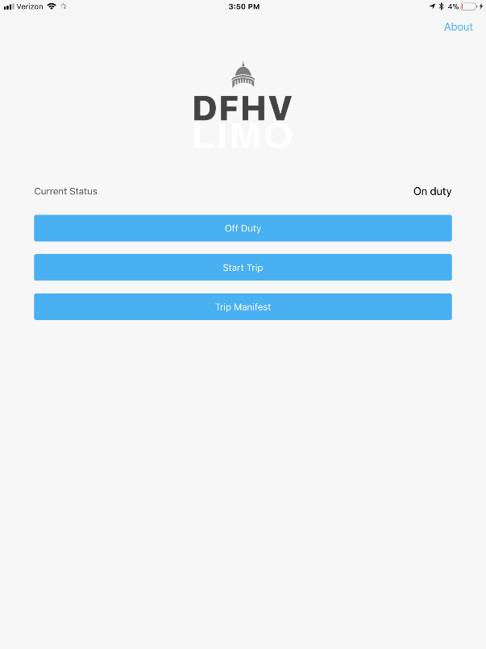
End Trip:
After completing the trip, tap "End trip" button:

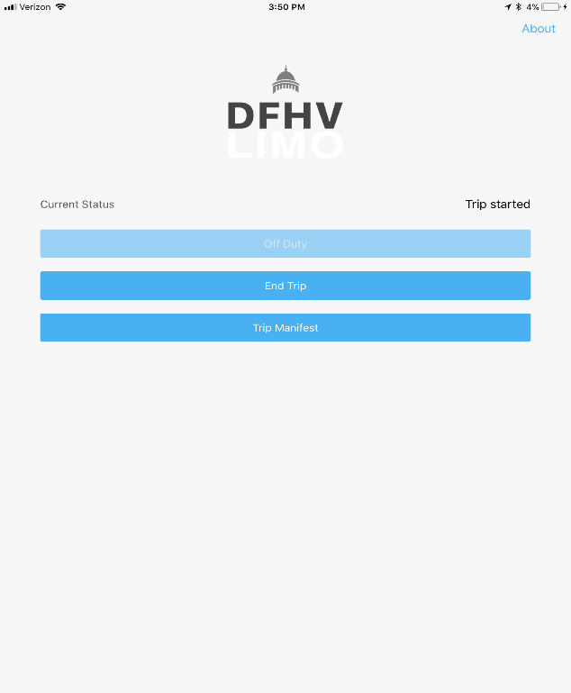
Enter total trip charge amount, number of passengers and tap "Done":

Trip History:
To view completed trips, click “Trip Manifest” button from the home screen:
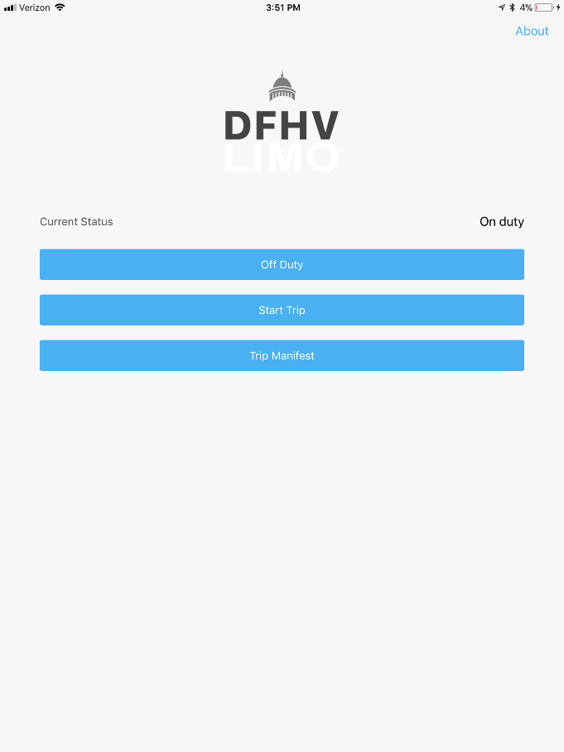
To view trip detail, click on the trip item in the list:
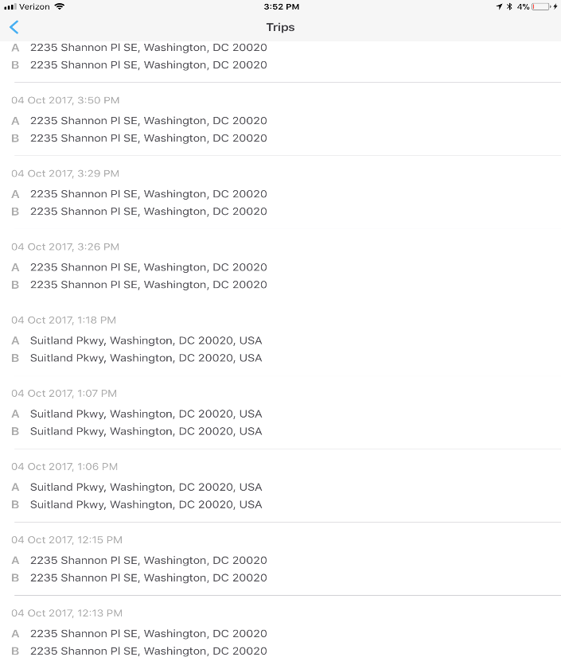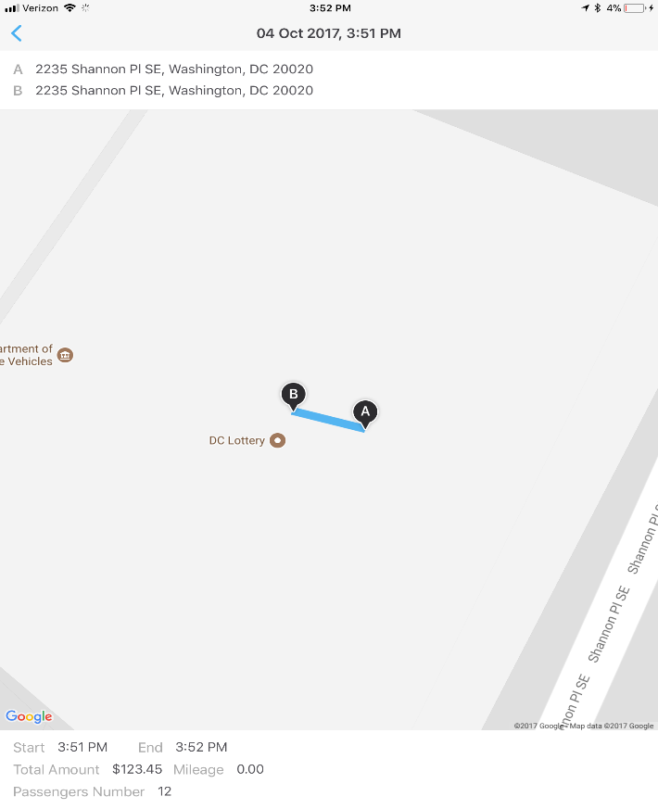

About (Logout):
To logout, click on the ABOUT link on right top corner of the app. A new screen will open with the driver details where Logout button will be present which user can click to logout:
