DFHV Non-District Limousine (NDL) License Authority Guide

Background:
In FY 2017 the Department of For Hire Vehicles started a pilot program by where Non-District Limousines can complete point to point trips within the District limits. The program is being extended through FY 2018. The legacy system has been transferred to the DFHV central licensing platform. New applicants and companies wishing to extend their authority will need to access the new system to complete the registration process.

New Application Process

Apply for NDL Authority:
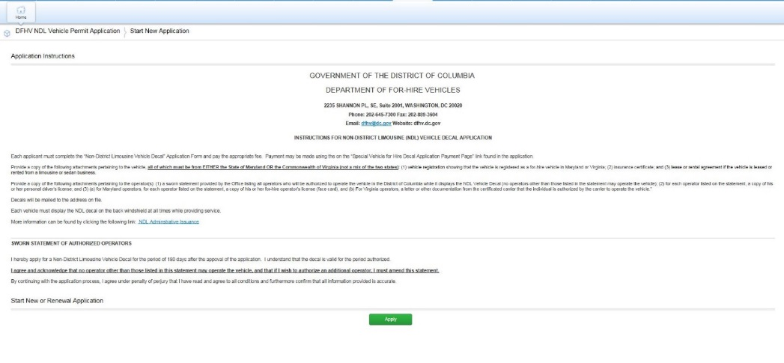
Access the DFHV NDL Permit Application by clicking the following link: https://tinyurl.com/NDL-Program​ to apply for NDL authority. Click on the Apply button to start the process

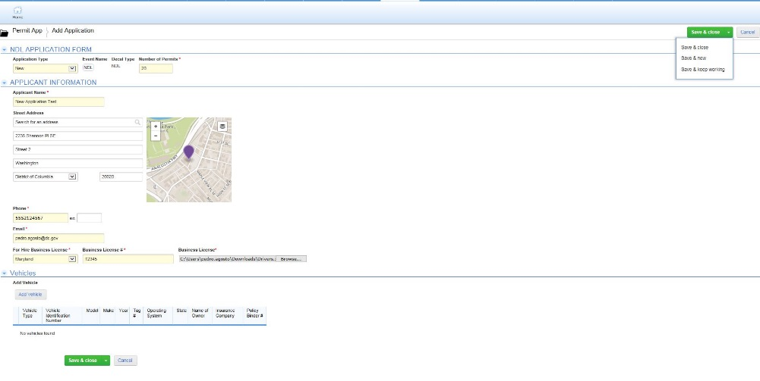
Select the New option from the application type dropdown list. Enter all the required information and click on the Save and Keep Working button found in the upper right-hand corner or lower left corner. Once saved you can click the Add Vehicle button to enter the vehicles for which you are requesting authority.
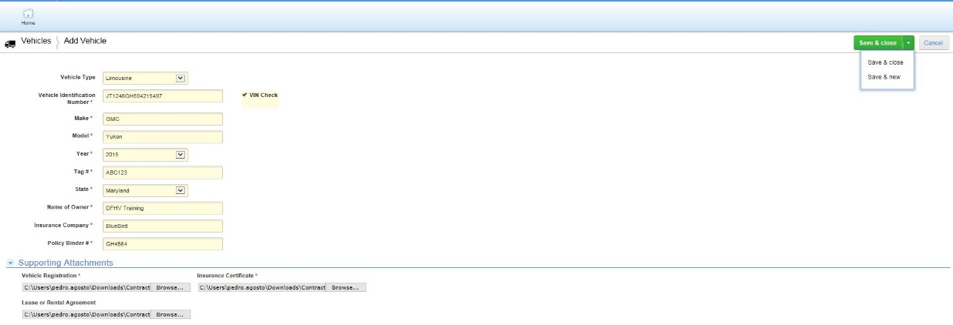
Enter all the requested information and press Save & Close if done or Save & New if you want to add more vehicles.

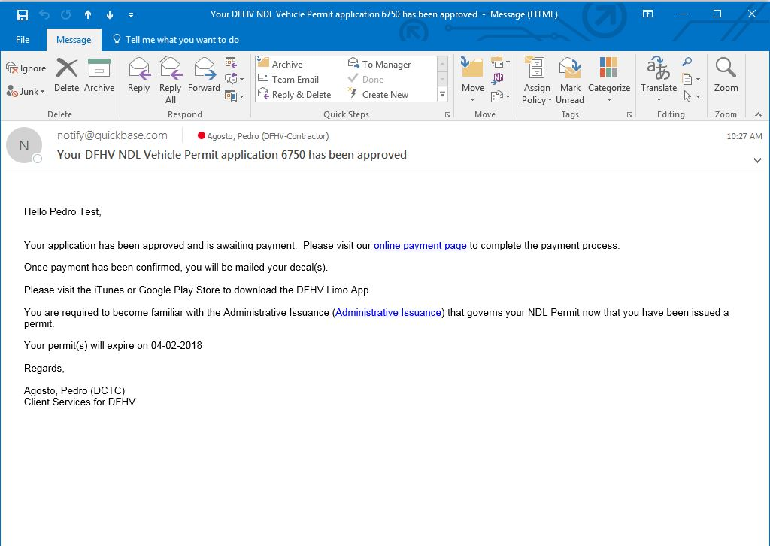
Once submitted the application will be reviewed by the Client Services team and if approved, you will receive an email with a link to pay for the vehicle licensing. Once payment has been processed, the vehicles will be registered in the systems and allowed to log into the Limo App.
Before drivers can use the Limo App, they need to be added to the Salesforce platform. Follow the instructions below to add operators.

Login:
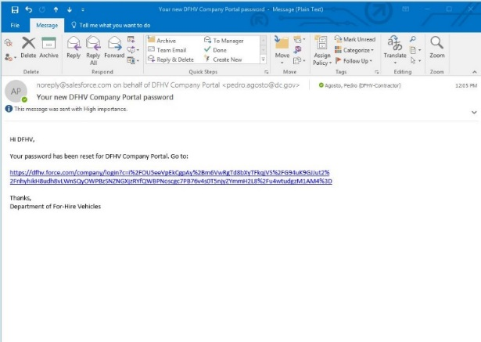
You will receive an email from support@salesforce.com with instructions on how to access your company self-service account. Click on the embedded link to access the portal.

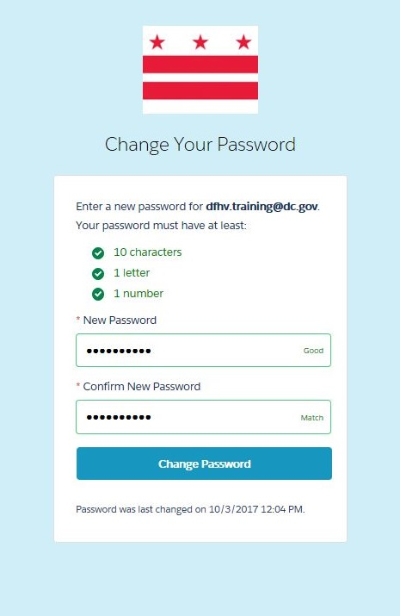
You will be asked to you change your password. Enter the new password, confirm and then press the Change Password button.

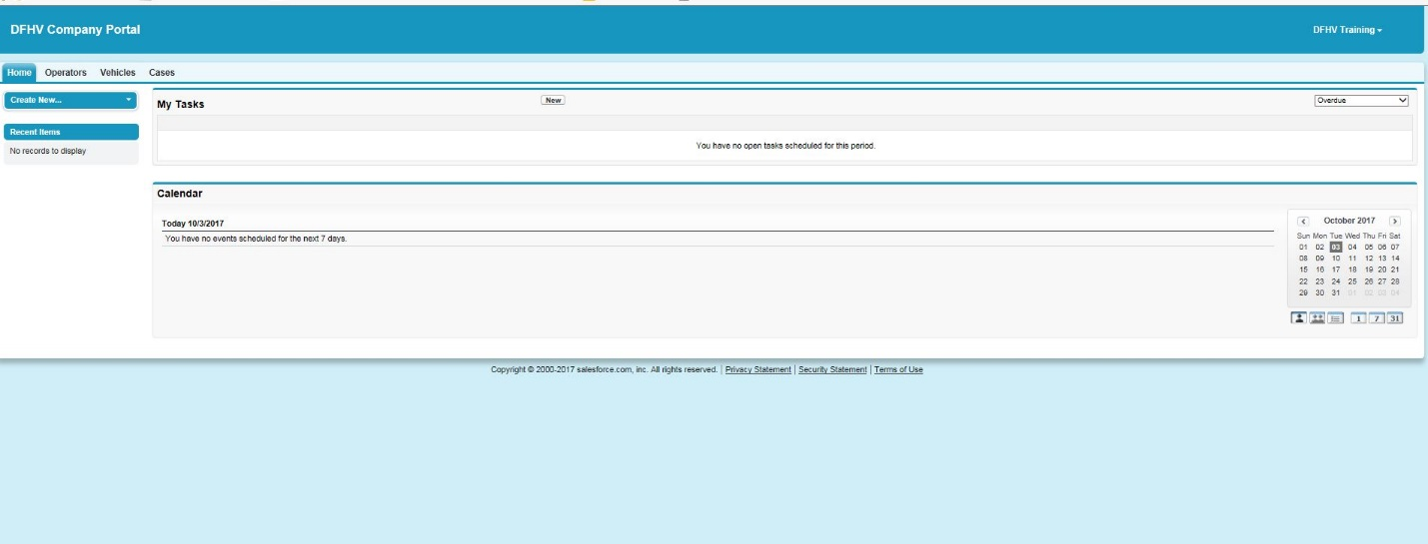
You will be directed to the Company Portal home page. The portal allows the user to view all vehicles assigned and operators assigned to your company.

Verify Vehicles:
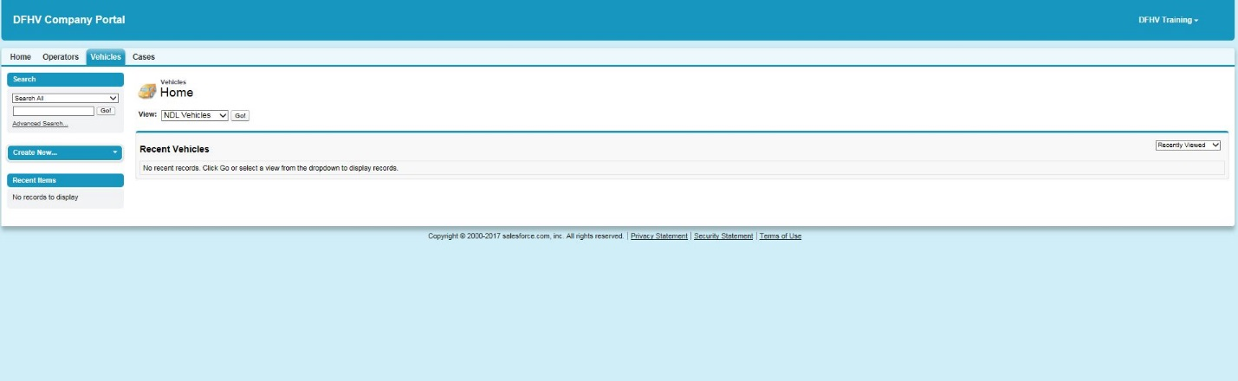
Click on the Vehicles tab to review all assigned vehicles.

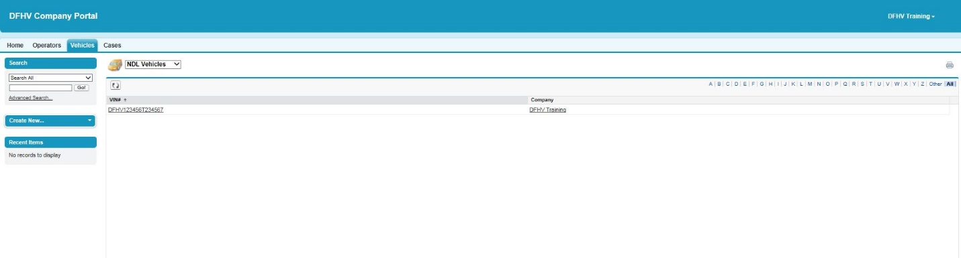
Click on the View dropdown list and choose NDL Vehicles. A list of all assigned vehicles will display.

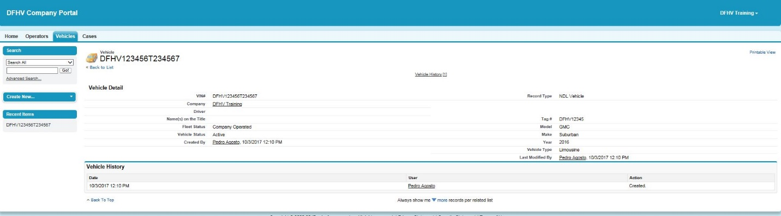
Click on the underlined VIN to display the vehicle detail information. Verify that the number of vehicles and vehicle detail is correct. If any of the information is not accurate, contact the DFHV Client Services team to correct it.

Update/Add Operators:
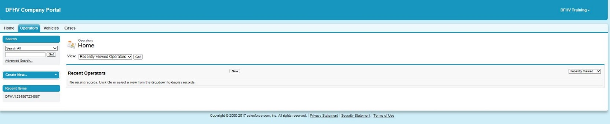
You are required to maintain a current list of limousine operators in the system. Click on the Operators tab to view operators assigned to your company.
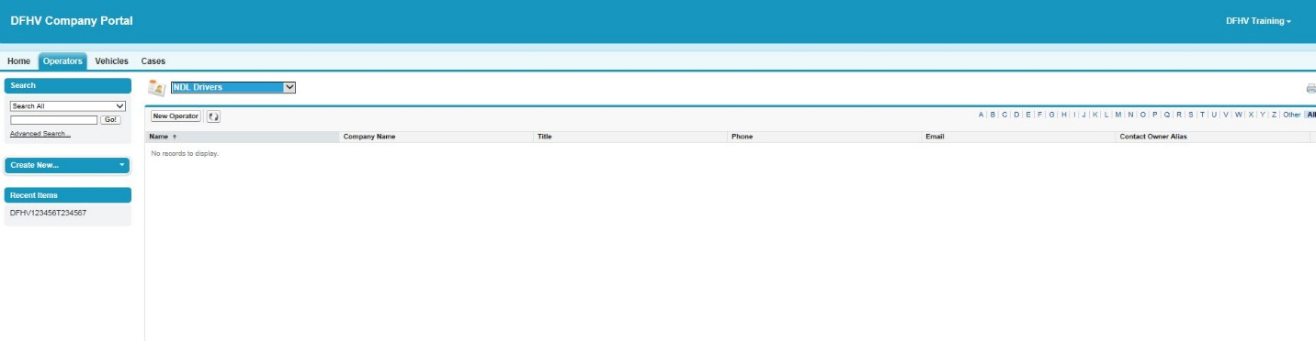
Click on the View dropdown list and choose NDL Drivers to view all drives assigned. Click on the New Operator button to add a driver.

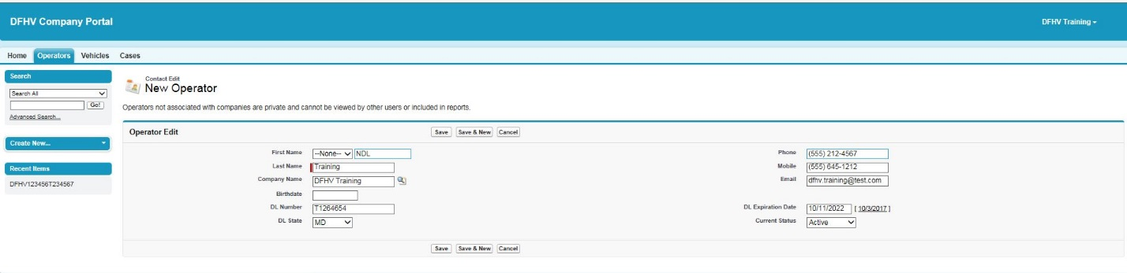
Enter the driver information on the form and click the Save button to finish or Save & New if you would like to add other drivers.

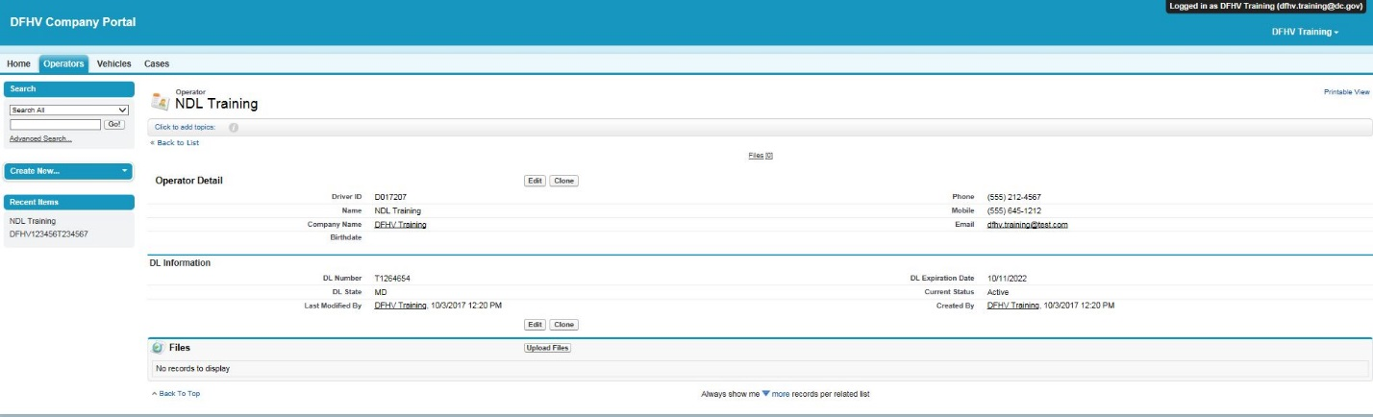
Please note the Driver ID field value. This will be ID required to log into the DFHV Limo App

